**INTRODUCTION**

This project aimed at helping farmers gain knowledge about the benefits and misfits of proper soil and crops.

The program contains the following options for the farmers to explore and widen their knowledge.

* **CROP HANDBOOK:** This option shows some useful data about the one of the soil type chosen by the user.
* **NEWSFEED:** This option shows the approximate percentage of most of the soil present in India and another sub option of the category shows our recent sales so that the farmer can determine whether he’d like to shop from us of not.
* **FERTILITY ANALYSER**: This option gives the user appropriate crops for their pH of soil.
* **FARMER’S SHOP**: This option provides the user a simple shop to buy equipment and seeds .

**SCHEMA OF SQL TABLE** 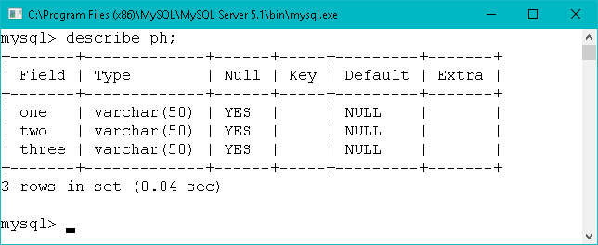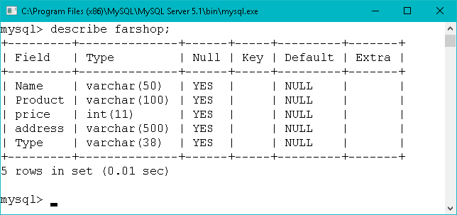

**USER DEFINED FUNCTIONS**

|  |  |
| --- | --- |
| **FUNCTION** | **USES** |
| def cs(): | Displays the contact information. |
| def buy(): | Passes the information of items to def credit. |
| def cash(): | Transfers user order data in a sql table. |
| def credit(): | Collects user data for order. |
| def track(): | Passes all the data related to ordered tractors cash(). |
| def fer(): | Passes all the data related to ordered fertilizers to cash(). |
| def SEE(): | Passes all the data related to ordered seeds to cash(). |
| def equ(): | Passes all the data related to ordered equipment to cash(). |
| def store(): | Shows the options for things to buy and collects data on desired item. |
| def al(): | Shows information about alluvial soil. |
| def bl(): | Shows information about black soil. |
| def red(): | Shows information about red soil. |
| def des(): | Shows information about desert soil. |
| def lat(): | Shows information about laterite soil. |
| def moun(): | Shows information about mountain soil. |
| def psoil(): | Shows a pie chart of soils in India. |
| def lm(): | Shows a pie chart of all sales made by the program store. |
| def grap(): | Creates a frame to show options of news feed. |
| def hand(): | Shows different kinds of soil to choose from to learn about. |
| def ph(): | Shows suggested crops for your soil according to pH. |
| def ferana(): | Gives the option to select your soil pH and tells how to do check soil pH. |

**MODULES USED**

|  |  |
| --- | --- |
| NAMES | FUNCTION |
| 1.Tkinter | For doing programing in GUI  window |
| 2. Matplotlib.pyplot | For plotting graphs |
| 3. Mysql.connector | For connecting python with mysql |

**SOURCE CODE**

from tkinter import *

from tkinter import messagebox

import matplotlib.pyplot as plt

m=Tk()

import mysql.connector

con = mysql.connector.connect(host="localhost",

user="root",

passwd="tiger",

database="system2")

def cs():

c=Frame(m)

c.configure(background="grey")

c.place(x=250,y=170)

z1=Label(c,text="VISIT: www.farmer.gov.in ",width=40,fg="purple",font=("ariel",14))

b=Button(c,text="BACK",bg="lightgrey",borderwidth=10,width=25,command=c.destroy)

z1.grid(row=0,column=0)

b.grid(row=1,column=0)

def buy(x,y,z):

credit(x,y,z)

def csh(x,y,z):

c=e.get()

c1=e3.get()

cursor1=con.cursor()

sql="insert into farshop values('"+c+"','"+x+"','"+y+"','"+c1+"','"+z+"')"

cursor1.execute(sql)

con.commit()

cursor1.close()

bi=Tk()

bi.geometry("500x500")

l=Label(bi,text= "NAME\t : "+c+"",fg="purple",font=("ariel",14))

l.place(x=50,y=50)

l1=Label(bi,text="PRODUCT : "+x+"",fg="purple",font=("ariel",14))

l1.place(x=50,y=100)

l2=Label(bi,text="PRICE\t : "+y+"",fg="purple",font=("ariel",14))

l2.place(x=50,y=150)

l3=Label(bi,text="Address\t : "+c1+"",fg="purple",font=("ariel",14))

l3.place(x=50,y=200)

l4=Label(bi,text="order succesful ,Your order will be ariving within 3 days",fg="purple",font=("ariel",14))

l4.place(x=10,y=250)

def credit(x,y,z):

k=Tk()

global e

global e3

k.geometry("500x500")

l=Label(k,text="Enter your name \t:",fg="purple",font=("ariel",14))

l.place(x=10,y=50)

l1=Label(k,text="Enter your card no. :",fg="purple",font=("ariel",14))

l1.place(x=10,y=100)

l2=Label(k,text="Enter your card pin :",fg="purple",font=("ariel",14))

l2.place(x=10,y=150)

l3=Label(k,text="Address\t\t:",fg="purple",font=("ariel",14))

l3.place(x=10,y=200)

e=Entry(k,textvariable=st)

e.place(x=250,y=50)

e1=Entry( k,text=IntVar())

e1.place(x=250,y=100)

e2=Entry(k,text=IntVar())

e2.place(x=250,y=150)

e3=Entry(k)

e3.place(x=250,y=200)

b=Button(k,text="PROCEED TO PAY",bg="red",borderwidth=10,command=lambda:csh(x,y,z))

b.place(x=180,y=350)

k.mainloop()

def trac():

t=Frame(m)

t.place(x=250,y=145)

t.configure(background="grey",)

p=PhotoImage(file="ab.PNG")

image=Label(t,image=p)

image.grid(row=0,column=2)

p1=PhotoImage(file="download.PNG")

image=Label(t,image=p1)

image.grid(row=1,column=2)

p2=PhotoImage(file="qwe.PNG")

image=Label(t,image=p2)

image.grid(row=2,column=2)

p3=PhotoImage(file="abcd.PNG")

image=Label(t,image=p3)

image.grid(row=3,column=2)

z1=Label(t,text="Mahindra yuvo 255DI,\n32 hp,Tractor,1500kg",width=30,fg="purple",font=("ariel",14))

z2=Button(t,text="BUY\n(Rs. 5.6lakh)",bg="red",borderwidth=10,command=lambda:buy('Mahindra yuvo 255DI','560000','Tractor'))

z3=Label(t,text="Mahindra yuvo 235DI,\n30 hp,Tractor,1200kg",width=30,fg="purple",font=("arabic",14))

z4=Button(t,text="BUY\n(Rs. 5.1lakh)",bg="red",borderwidth=10,command=lambda:buy('Mahindra yuvo 235DI','510000','Tractor'))

z5=Label(t,text="Mahindra mm 220DI,\n15 hp,Tractor,1600kg",width=30,fg="purple",font=("arabic",14))

z6=Button(t,text="BUY\n(Rs. 5.3lakh)",bg="red",borderwidth=10,command=lambda:buy('Mahindra mm 220DI','530000','Tractor'))

z7=Label(t,text="Mahindra rie 260DI,\n40 hp,Tractor,1800kg",width=30,fg="purple",font=("arabic",14))

z8=Button(t,text="BUY\n(Rs. 7.3lakh)",bg="red",borderwidth=10,command=lambda:buy('Mahindra rie 260DI','730000','Tractor'))

b=Button(t,text="BACK",bg="lightgrey",borderwidth=10,width=25,command=t.destroy)

z7.grid(row=3,column=0)

z8.grid(row=3,column=1)

z6.grid(row=2,column=1)

z5.grid(row=2,column=0)

z3.grid(row=1,column=0)

z4.grid(row=1,column=1)

z2.grid(row=0,column=1)

z1.grid(row=0,column=0)

b.grid(row=4,column=0)

t.mainloop()

def Fer():

fe=Frame(m)

fe.configure(background="grey")

fe.place(x=250,y=170)

z1=Label(fe,text="Akash Bio \nStimulant ,25kg",width=40,fg="purple",font=("ariel",14))

z2=Button(fe,text="BUY\n(Rs. 650 )",bg="red",borderwidth=10,command=lambda:buy('Akash Bio Stimulant','650','Fertilizers'))

z3=Label(fe,text="Super Potassium\nHumate,5kg",fg="purple",width=40,font=("arabic",14))

z4=Button(fe,text="BUY\n(Rs.5000 )",bg="red",borderwidth=10,command=lambda:buy('Super Potassium Humate','5000','Fertilizers'))

z5=Label(fe,text=" Loar organic \nfertilizer ",fg="purple",width=40,font=("arabic",14))

z6=Button(fe,text="BUY\n(Rs.3700 )",bg="red",borderwidth=10,command=lambda:buy('Loar organic fertilizers','3700','Fertilizers'))

z7=Label(fe,text="bio star organic\nfertilizer",fg="purple",width=40,font=("arabic",14))

z8=Button(fe,text="BUY\n(Rs.4500 )",bg="red",borderwidth=10,command=lambda:buy('bio star organic fertilizers','4500','Fertilizers'))

b=Button(fe,text="BACK",bg="lightgrey",borderwidth=10,width=35,command=fe.destroy)

z7.grid(row=3,column=0)

z8.grid(row=3,column=1)

z6.grid(row=2,column=1)

z5.grid(row=2,column=0)

z3.grid(row=1,column=0)

z4.grid(row=1,column=1)

z2.grid(row=0,column=1)

z1.grid(row=0,column=0)

b.grid(row=4,column=0)

fe.mainloop()

def SEE():

se=Frame(m)

se.configure(background="grey")

se.place(x=200,y=145)

z1=Label(se,text="BLUE BERRIES,1kg",width=20,height=5,fg="red",font=("ariel",10))

z2=Button(se,text="BUY\n(Rs. 800 )",bg="red",borderwidth=10,width=18,command=lambda:buy('BLUE BERRIES','800','Seed'))

z3=Label(se,text="IRISH POTATOES,1kg",width=20,height=5,fg="red",font=("arabic",10))

z4=Button(se,text="BUY\n(Rs.1600)",bg="red",borderwidth=10,width=18,command=lambda:buy('Irish potatoes','1600','Seed'))

z5=Label(se,text="SWEET POTATOES,1kg",width=20,height=5,fg="red",font=("arabic",10))

z6=Button(se,text="BUY\n(Rs.1800)",bg="red",borderwidth=10,width=18,command=lambda:buy('Sweet potatoes','1800','Seed'))

z7=Label(se,text="BARLEY,1kg",fg="red",width=20,height=5,font=("arabic",10))

z8=Button(se,text="BUY\n(Rs. 900 )",bg="red",borderwidth=10,width=18,command=lambda:buy('Barley','900','Seed'))

z9=Label(se,text="COTTON,1kg",fg="red",width=20,height=5,font=("arabic",10))

z10=Button(se,text="BUY\n(Rs.1800)",bg="red",borderwidth=10,width=18,command=lambda:buy('Cotton','1800','Seed'))

z11=Label(se,text="SUGAR BEETS,1kg",width=20,height=5,fg="red",font=("arabic",10))

z12=Button(se,text="BUY\n(Rs.5930)",bg="red",borderwidth=10,width=18,command=lambda:buy('Sugar beets','5930','Seed'))

b=Button(se,text="BACK",bg="lightgrey",borderwidth=10,width=35,command=se.destroy)

z11.grid(row=2,column=2)

z12.grid(row=3,column=2)

z9.grid(row=2,column=1)

z10.grid(row=3,column=1)

z7.grid(row=2,column=0)

z8.grid(row=3,column=0)

z6.grid(row=1,column=2)

z5.grid(row=0,column=2)

z3.grid(row=0,column=1)

z4.grid(row=1,column=1)

z2.grid(row=1,column=0)

z1.grid(row=0,column=0)

b.grid(row=4,column=1)

se.mainloop()

def equ():

e=Frame()

e.place(x=250,y=145)

e.configure(background="grey")

z1=Label(e,text="CULTIVATOR",fg="purple",width=40,height=2,font=("ariel",14))

z2=Button(e,text="BUY\n(Rs.80000)",bg="red",borderwidth=10,command=lambda:buy('Cultivator','80000','Equipment'))

z3=Label(e,text="PLOWS",fg="purple",width=40,height=2,font=("arabic",14))

z4=Button(e,text="BUY\n(Rs.35000)",bg="red",borderwidth=10,command=lambda:buy('Plows','35000','Equipment'))

z5=Label(e,text="HARROWS",fg="purple",width=40,height=2,font=("arabic",14))

z6=Button(e,text="BUY\n(Rs.16000)",bg="red",borderwidth=10,command=lambda:buy('Harrows','16000','Equipment'))

z7=Label(e,text="SPRAYERS",fg="purple",width=40,height=2,font=("arabic",14))

z8=Button(e,text="BUY\n(Rs. 4500)",bg="red",borderwidth=10,command=lambda:buy('Sprayers','4500','Equipment'))

b=Button(e,text="BACK",bg="lightgrey",borderwidth=10,width=35,command=e.destroy)

z7.grid(row=3,column=0)

z8.grid(row=3,column=1)

z6.grid(row=2,column=1)

z5.grid(row=2,column=0)

z3.grid(row=1,column=0)

z4.grid(row=1,column=1)

z2.grid(row=0,column=1)

z1.grid(row=0,column=0)

b.grid(row=4,column=0)

e.mainloop()

def store():

s=Frame(m)

s.configure(background="light gray")

s.place(x=130,y=210)

z=Label(s,text="STORE",width=13,height=2,fg="WHITE",bg="blue",font=("fixedsys",18))

l1=Button(s,text=" TRACTORS ",borderwidth=10,bg="powder blue",font=("fixedsys",18),command=trac)

l1.grid(row=2,column=0)

l2=Button(s,text=" FERTILIZERS",borderwidth=10,bg="powder blue",font=("fixedsys",18),command=Fer)

l2.grid(row=2,column=2)

l3=Button(s,text=" SEEDS ",borderwidth=10,bg="powder blue",font=("fixedsys",18),command=SEE)

l3.grid(row=3,column=0)

l4=Button(s,text=" EQUIPMENT ",borderwidth=10,bg="powder blue",font=("fixedsys",18),command=equ)

l4.grid(row=3,column=1)

b=Button(s,text=" BACK ",borderwidth=10,bg="light grey",font=("fixedsys",18),command=s.destroy)

b.grid(row=3,column=2)

z.grid(row=2,column=1)

def al():

a=Frame(m)

a.configure(background="orange")

a.place(x=150,y=200)

Label(a,text=">They are mostly flat and regular soils and are best suited for agriculture.\n>They are best suited to irrigation and respond well to canal and well/tube-well\n irrigation.\n>They yield splendid crops of rice, wheat, sugarcane, tobacco, cotton, jute, maize, \noilseeds, vegetables and fruits.",font=("fixedsys",15),fg="white",bg="black").grid(row=0,column=0)

b1=Button(a,text="STORE",command=store,font=("fixedsys",15),fg="black",borderwidth=5,bg="yellow",width=25).grid(row=2,column=0)

b6=Button(a,text="BACK",font=("fixedsys",15),fg="black",borderwidth=10,command=a.destroy,bg="lightblue",width=25).grid(row=3,column=0)

a.mainloop()

def bl():

b=Frame(m)

b.configure(background="orange")

b.place(x=150,y=200)

Label(b,text=">These soils are best suited for cotton crop. Hence these soils are called as\n regur and black cotton soils.\n>Other major crops grown on the black soils include wheat, jowar, linseed, virginia \ntobacco, castor, sunflower and millets. ",font=("fixedsys",15),fg="white",bg="black").grid(row=0,column=0)

b1=Button(b,text="STORE",command=store,font=("fixedsys",15),fg="black",borderwidth=5,bg="yellow",width=25).grid(row=2,column=0)

b6=Button(b,text="BACK",font=("fixedsys",15),fg="black",borderwidth=10,command=b.destroy,bg="lightblue",width=25).grid(row=3,column=0)

b.mainloop()

def red():

r=Frame(m)

r.configure(background="orange")

r.place(x=150,y=200)

Label(r,text=">They are mostly flat and regular soils and are best suited for agriculture.\n>They are best suited to irrigation and respond well to canal and well/tube-well\n irrigation.\n>They yield splendid crops of rice, wheat, sugarcane, tobacco, cotton, jute, maize, \noilseeds, vegetables and fruits.",font=("fixedsys",15),fg="white",bg="black").grid(row=0,column=0)

b1=Button(r,text="STORE",command=store,font=("fixedsys",15),fg="black",borderwidth=5,bg="yellow",width=25).grid(row=2,column=0)

b6=Button(r,text="BACK",font=("fixedsys",15),fg="black",borderwidth=10,command=r.destroy,bg="lightblue",width=25).grid(row=3,column=0)

r.mainloop()

def des():

d=Frame(m)

d.configure(background="orange")

d.place(x=150,y=200)

Label(d,text=">They are mostly flat and regular soils and are best suited for agriculture.\n>They are best suited to irrigation and respond well to canal and well/tube-well\n irrigation.\n>They yield splendid crops of rice, wheat, sugarcane, tobacco, cotton, jute, maize, \noilseeds, vegetables and fruits.",font=("fixedsys",15),fg="white",bg="black").grid(row=0,column=0)

b1=Button(d,text="STORE",command=store,font=("fixedsys",15),fg="black",borderwidth=5,bg="yellow",width=25).grid(row=2,column=0)

b6=Button(d,text="BACK",font=("fixedsys",15),fg="black",borderwidth=10,command=d.destroy,bg="lightblue",width=25).grid(row=3,column=0)

d.mainloop()

def lat():

l=Frame(m)

l.configure(background="orange")

l.place(x=150,y=200)

Label(l,text=">They are mostly flat and regular soils and are best suited for agriculture.\n>They are best suited to irrigation and respond well to canal and well/tube-well\n irrigation.\n>They yield splendid crops of rice, wheat, sugarcane, tobacco, cotton, jute, maize, \noilseeds, vegetables and fruits.",font=("fixedsys",15),fg="white",bg="black").grid(row=0,column=0)

b1=Button(l,text="STORE",command=store,font=("fixedsys",15),fg="black",borderwidth=5,bg="yellow",width=25).grid(row=2,column=0)

b6=Button(l,text="BACK",font=("fixedsys",15),fg="black",borderwidth=10,command=l.destroy,bg="lightblue",width=25).grid(row=3,column=0)

l.mainloop()

def moun():

mo=Frame(m)

mo.configure(background="orange")

mo.place(x=150,y=200)

Label(mo,text=">They are mostly flat and regular soils and are best suited for agriculture.\n>They are best suited to irrigation and respond well to canal and well/tube-well\n irrigation.\n>They yield splendid crops of rice, wheat, sugarcane, tobacco, cotton, jute, maize, \noilseeds, vegetables and fruits.",font=("fixedsys",15),fg="white",bg="black").grid(row=0,column=0)

b1=Button(mo,text="STORE",command=store,font=("fixedsys",15),fg="black",borderwidth=5,bg="yellow",width=25).grid(row=2,column=0)

b6=Button(mo,text="BACK",font=("fixedsys",15),fg="black",borderwidth=10,command=mo.destroy,bg="lightblue",width=25).grid(row=3,column=0)

mo.mainloop()

def psoil():

x=[22,29,28,2,6,1,2,7]

y=["Alluvial ","Black ","red and yellow","laterite","arid","saline","peaty and organic","forest"]

plt.pie(x,labels=y,shadow="true",autopct='%1.1f%%',explode=(0.05,0.05,0.05,0.05,0.05,0.05,0.05,0.05))

plt.show()

def lm():

cursor1=con.cursor()

sql="select count(*),Type from farshop group by type;"

cursor1.execute(sql)

rec=cursor1.fetchall()

l=[]

l1=[]

colours=["r","g","b","c"]

c=0

for i in rec:

l.append(i[0])

l1.append(i[1])

c=c+1

plt.pie(l,labels=l1,shadow="true",autopct='%1.1f%%',explode=(0.05,0.05,0.05,0.05))

plt.show()

def grap():

g=Frame(m)

g.configure(background="green")

g.place(x=250,y=220)

b1=Button(g,text="RECENT SALES",font=("fixedsys",15),fg="black",borderwidth=20,command=lm,bg="lightgreen",width=25).grid(row=0,column=0)

b2=Button(g,text="SOILS IN INDIA",font=("fixedsys",15),fg="black",borderwidth=20,command=psoil,bg="lightgreen",width=25).grid(row=0,column=1)

b1=Button(g,text="BACK",font=("fixedsys",15),fg="black",borderwidth=20,command=g.destroy,bg="LIGHTGREY",width=25).grid(row=1,column=0)

g.mainloop()

def hand():

n=Frame(m)

n.configure(background="orange")

n.place(x=150,y=200)

x=Label(n,text="TYPES OF SOILS",font=("fixedsys",20),fg="brown",bg="black").grid(row=0,column=1)

b1=Button(n,text=" 1. Alluvial Soils ",font=("fixedsys",15),command=al,borderwidth=5,fg="black",bg="yellow",width=25).grid(row=1,column=0)

b2=Button(n,text=" 2. Black Soils ",font=("fixedsys",15),command=bl,fg="black",borderwidth=5,bg="yellow",width=25).grid(row=2,column=0)

b3=Button(n,text=" 3. Red Soils ",font=("fixedsys",15),command=red,fg="black",borderwidth=5,bg="yellow",width=25).grid(row=1,column=1)

b4=Button(n,text=" 4. Desert Soils ",font=("fixedsys",15),command=des,fg="black",borderwidth=5,bg="yellow",width=25).grid(row=2,column=1)

b5=Button(n,text=" 5. Laterite Soils ",font=("fixedsys",15),command=lat,fg="black",borderwidth=5,bg="yellow",width=25).grid(row=1,column=2)

b6=Button(n,text=" 6. Mountain Soils ",font=("fixedsys",15),command=moun,fg="black",borderwidth=5,bg="yellow",width=25).grid(row=2,column=2)

b7=Button(n,text="BACK",font=("fixedsys",15),fg="black",borderwidth=10,command=n.destroy,width=25).grid(row=3,column=1)

n.mainloop()

def ph(a):

fe.destroy()

ph=Frame(m)

ph.configure(background="orange")

ph.place(x=220,y=200)

cursor1=con.cursor()

if a==1:

sql="select one from ph"

cursor1.execute(sql)

rec=cursor1.fetchall()

c=0

for i in rec:

c=c+1

for j in i:

x=Label(ph,text=str(j)+"\n",font=("Ariel",20),fg="Blue",bg="orange").grid(row=c,column=1)

elif a==2:

sql="select two from ph"

cursor1.execute(sql)

rec=cursor1.fetchall()

c=0

for i in rec:

c=c+1

for j in i:

x=Label(ph,text=str(j)+"\n",font=("Ariel",20),fg="Blue",bg="orange").grid(row=c,column=1)

elif a==3:

sql="select three from ph"

cursor1.execute(sql)

rec=cursor1.fetchall()

c=0

for i in rec:

c=c+1

for j in i:

x=Label(ph,text=str(j)+"\n",font=("Ariel",20),fg="Blue",bg="orange").grid(row=c,column=1)

b7=Button(ph,text="BACK",font=("fixedsys",13),fg="black",borderwidth=10,command=ph.destroy,width=60).grid(row=15,column=1)

ph.mainloop()

def ferana():

global fe

fe=Frame(m)

fe.configure(background="orange")

fe.place(x=220,y=135)

s0=Label(fe,text=" ",bg="orange",font=("ariel",14)).grid(row=0,column=1)

l=Label(fe,text="STEP 1: Buy a pH paper from your nearest chemist. ",fg="blue",font=("ariel",12)).grid(row=1,column=1)

s=Label(fe,text=" ",bg="orange",font=("ariel",14)).grid(row=2,column=1)

l1=Label(fe,text="STEP 2: Collect some of your soil in a bowl and add water. ",fg="blue",font=("ariel",12)).grid(row=3,column=1)

s1=Label(fe,text=" ",bg="orange",font=("ariel",14)).grid(row=4,column=1)

l2=Label(fe,text="STEP 3: Put one end of the pH paper to the solution. ",fg="blue",font=("ariel",12)).grid(row=5,column=1)

s2=Label(fe,text=" ",bg="orange",font=("ariel",14)).grid(row=6,column=1)

l3=Label(fe,text="STEP 4: Check the ph from a ph scale and Enter the value below. ",fg="blue",font=("ariel",12)).grid(row=7,column=1)

s3=Label(fe,text=" ",bg="orange",font=("ariel",14)).grid(row=8,column=1)

b=Button(fe,text="5.0 - 5.5",font=("fixedsys",13),fg="black",command=lambda:ph(1),borderwidth=3,width=60).grid(row=9,column=1)

b1=Button(fe,text="5.5 - 6.5",font=("fixedsys",13),fg="black",command=lambda:ph(2),borderwidth=3,width=60).grid(row=11,column=1)

b=Button(fe,text="6.5 - 7.0",font=("fixedsys",13),fg="black",command=lambda:ph(3),borderwidth=3,width=60).grid(row=13,column=1)

b7=Button(fe,text="BACK",font=("fixedsys",13),fg="black",borderwidth=10,command=fe.destroy,width=60).grid(row=15,column=1)

fe.mainloop()

far=PhotoImage(file="1000x.PNG")

image=Label(m,image=far)

image.grid(row=0,column=0)

m.configure(background="orange")

m.geometry("950x500")

m.title("\t\t\t FARMERS GUIDE\t\t")

Label(m,text=" FARMERS GUIDE ",font=("fixedsys",30),fg="white",bg="black").place(x=230,y=0)

cat=Frame(m)

cat.place(x=120,y=100)

b1=Button(cat,text="CROP HANDBOOK ",font=("fixedsys",15),fg="black",bg="yellow",command=hand,borderwidth=5,width=20).grid(row=1,column=0)

b2=Button(cat,text="NEWSFEED",font=("fixedsys",15),fg="black",bg="yellow",command=grap,borderwidth=5,width=15,).grid(row=1,column=1)

b3=Button(cat,text="FERTILITY ANALYSER",font=("fixedsys",15),command=ferana,fg="black",bg="yellow",borderwidth=5,width=20).grid(row=1,column=2)

b4=Button(cat,text="FARMER'S SHOP",font=("fixedsys",15),fg="black",command=store,bg="yellow",borderwidth=5,width=18).grid(row=1,column=3)

b6=Button(cat,text="CONTACT US",font=("fixedsys",15),fg="black",bg="yellow",command=cs,borderwidth=5,width=12).grid(row=1,column=4)

st=StringVar()

m.mainloop()

**OUTPUTS AND INPUTS**

**HOMEPAGE**

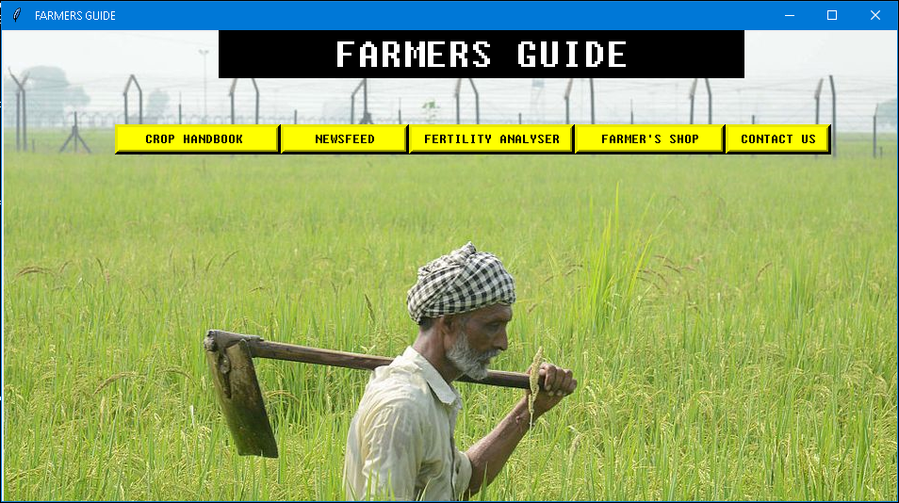

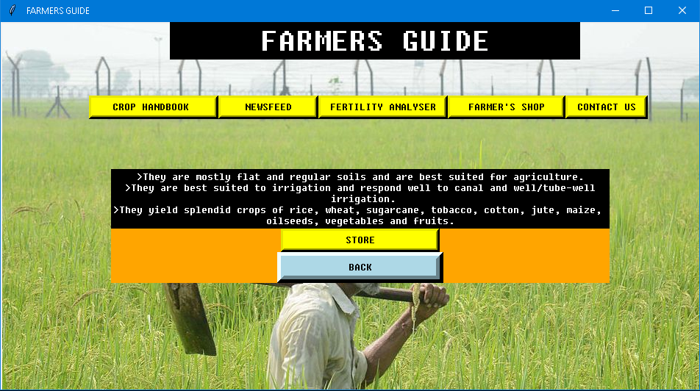**CROP HANDBOOK**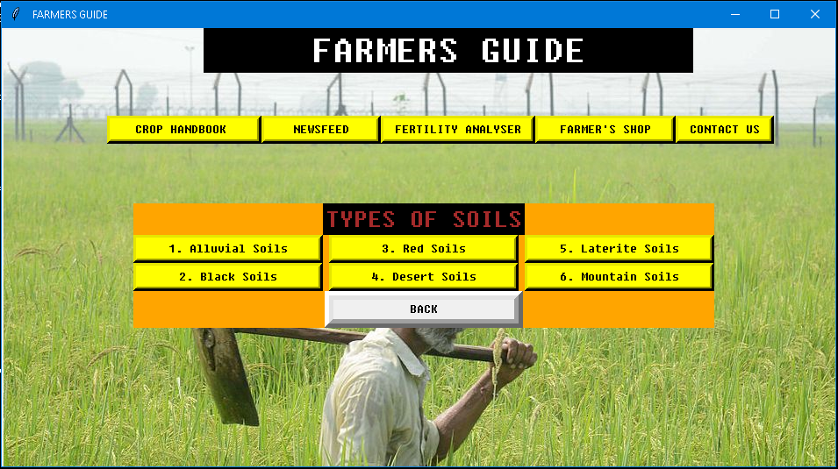

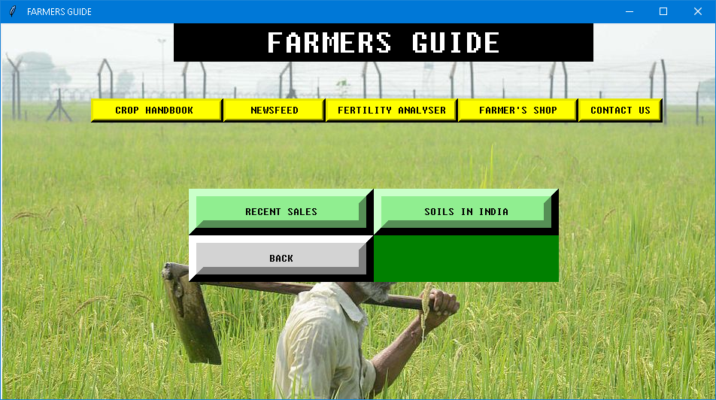**NEWSFEED**

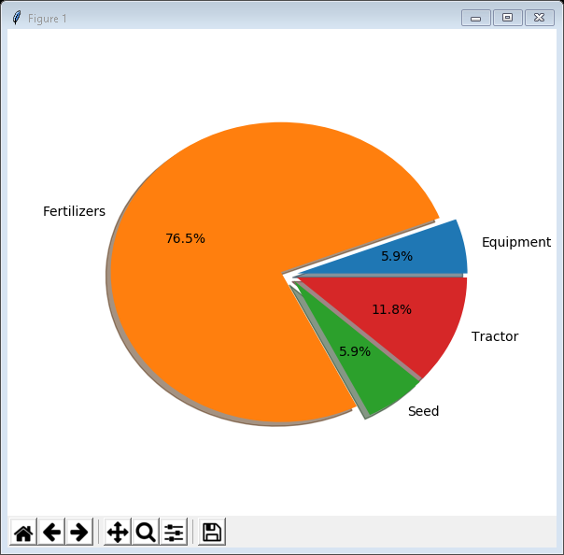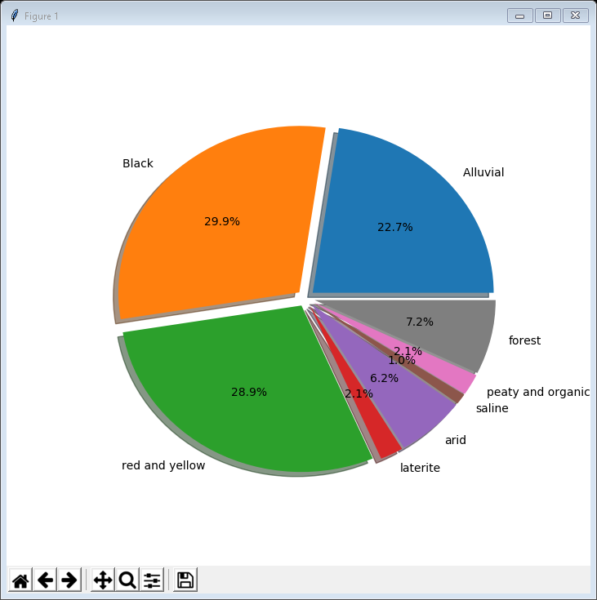 **SOILS IN INDIA RECENT SALES**

**FERTILITY ANALYSER**

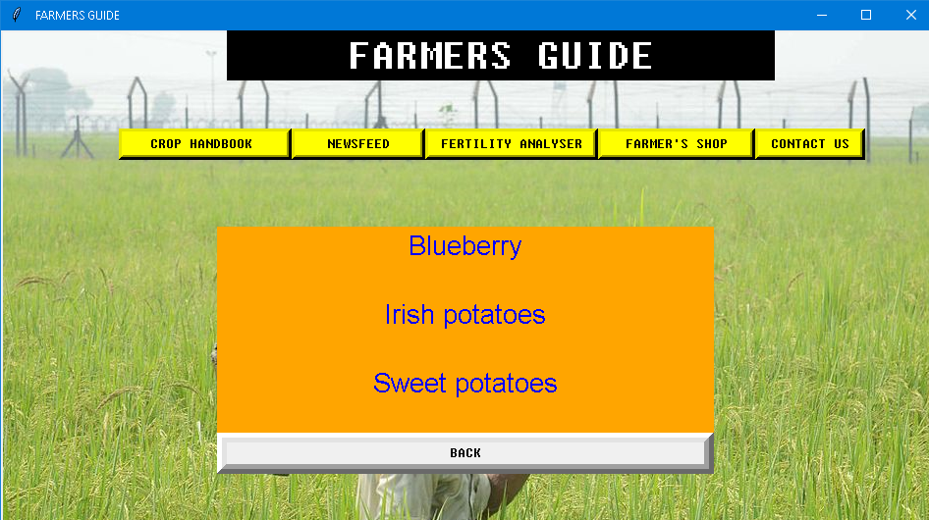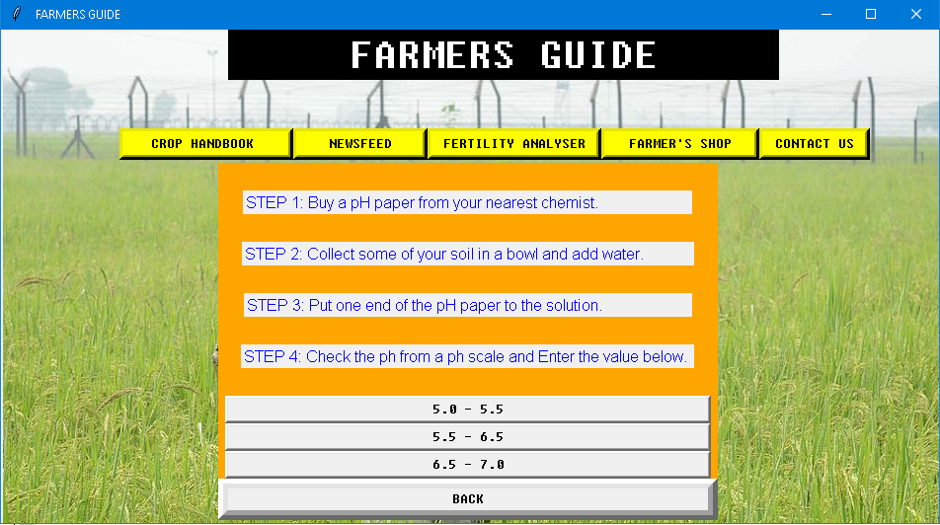

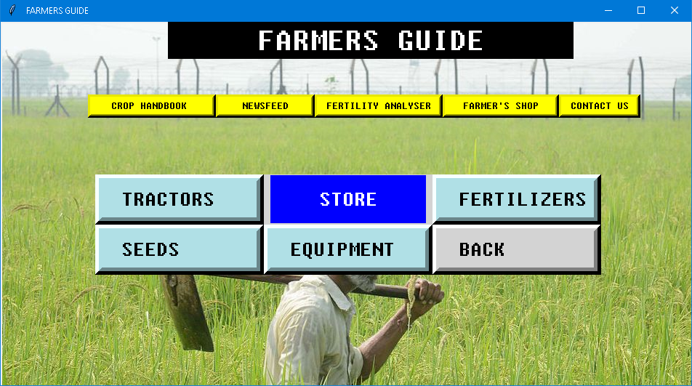 **FARMERS SHOP**

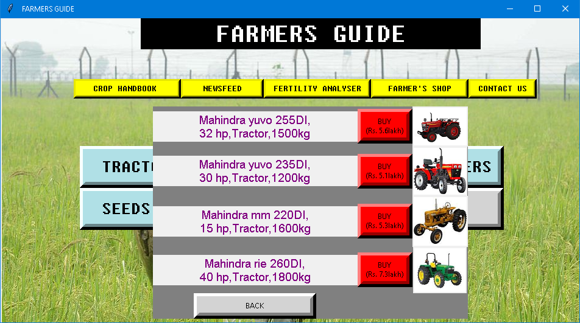

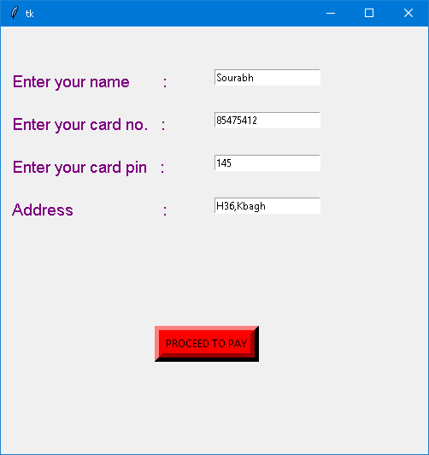

**BILL**

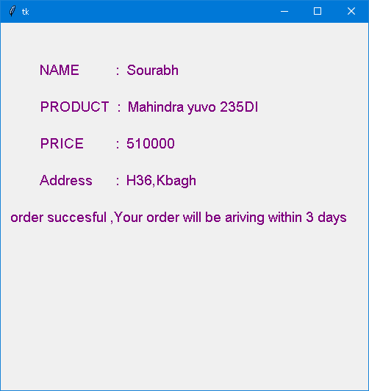

**CONTACT US**

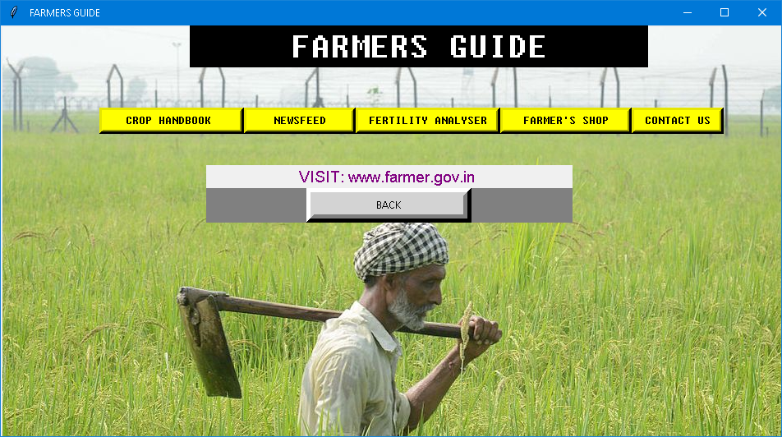

**SQL TABLES**

**RECENT SALES**

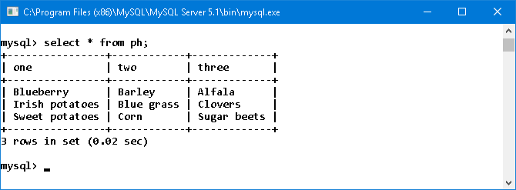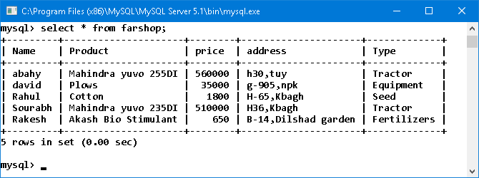

pH TABLE

BIBLOGRAPHY

1. Site :www.farmer.gov.in

2.Books :Computer science with

Python Sumita Arora,